On Thursday, 19 February 2026, between 0100hrs and 0300hrs, the Security Operations Team, acting upon intelligence, proceeded to the Old Salman Community Mining Site. Upon arrival, the Team observed four (4) excavators, comprising two (2) SANY and two (2) XCMG machines, parked with no intruder present at the location. During inspection, it was discovered that all four (4) excavators had their control boards and monitors disconnected. The Team subsequently secured and trammed one (1) XCMG excavator, Serial Number 1535/8144391.00, to the ARL Plant Site (Traffic) for safe custody.

Subsequently, on Monday 23 February 2026, between 1203hrs and 1250hrs, four (4) individuals, namely Doc Mends Annor (0542620245), Abdul Rahaman, Nuhu Sheik, and Nazir Abdullah, purportedly representing Namova Ghana Limited, led by Abraham Kwofie, met with ARL Management to claim ownership of the confiscated excavator under ARL custody. Mr. Caleb Mends alleged that they had been informed by the Ellembelle District Chief Executive (DCE) for reclamation project at Awulezo–Bamiankor and were subsequently invited to undertake similar activities within the Ellembelle District. Thus, their activities at Old Salman Community Mining Site.
ARL Management declined to release the excavator and clarified that no formal communication had been received from the DCE regarding such an arrangement. The delegation was formally advised to channel any concerns or proposals through official written communication to ARL Management for proper review and engagement. ARL respectfully seeks further Police investigation into the matter.

On Thursday 23rd April 2026, between 0710hrs and 0940hrs, the joint Security Operations Team comprising AU Fields and ARL Security, led by the Security Superintendent conducted a special patrol at Akango South following receipt of intelligence on illegal mining activities. The Team spotted five (5) excavators, one (1) dozer and several wooden structures with Ghanaian and Chinese nationals present on site. The Team successfully trammed four (4) of the five (5) excavators to Plant Site (Traffic) and retrieved three (3) excavator keys. However, one (1) excavator and the dozer which were unserviceable without control boards remained on site. The Team subsequently apprehended five (5) suspects identified as Ibrahim Moro (42 years), Isaac Donkor (52 years), Abdalah Ibrahim (17 years), Almond Tweneboah (40 years), Luo Zhiqiang, Chinese national (42 years) and demolished the structures on site. The suspects were handed over to Axim Divisional Police for further action while the three (3) retrieved excavator keys were retained by ARL security.

During investigation, the Suspects admitted working at the site where they were apprehended and claimed were employed by NAMOVA GH LTD who introduced them to the site. They further stated that, the seized excavators belongs to NAMOVA GH LTD.

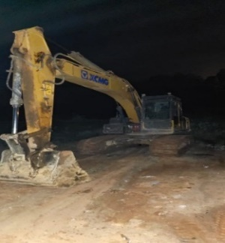
Picture showing the confiscated excavator parked at ARL Sit (Traffic).
Picture showing the excavator parked at Salman Old Community Mining site
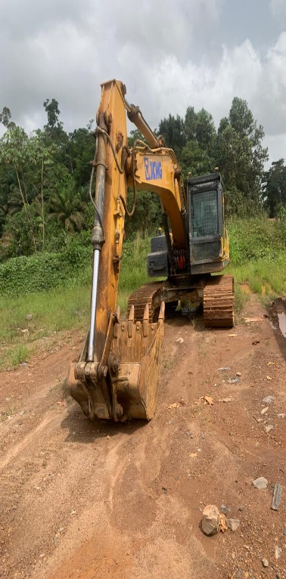
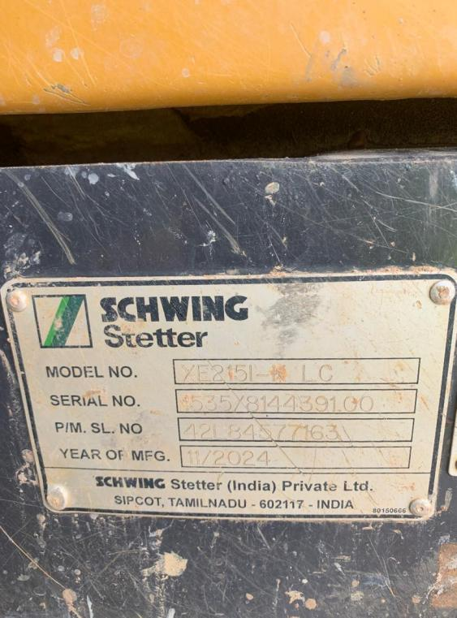
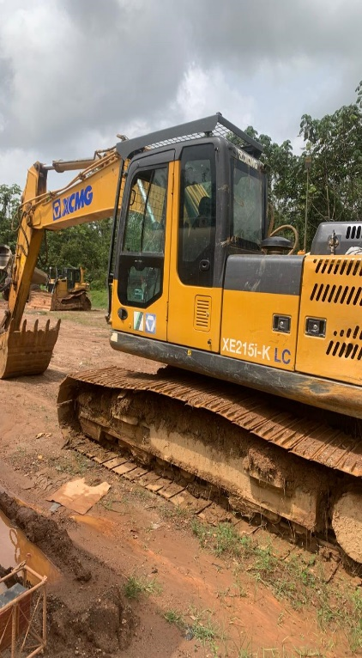
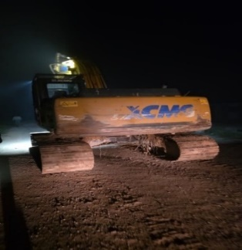
(SOURCE: ARL SEC 2026)

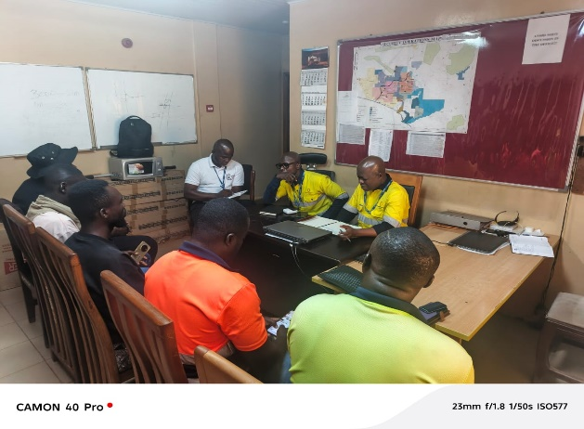
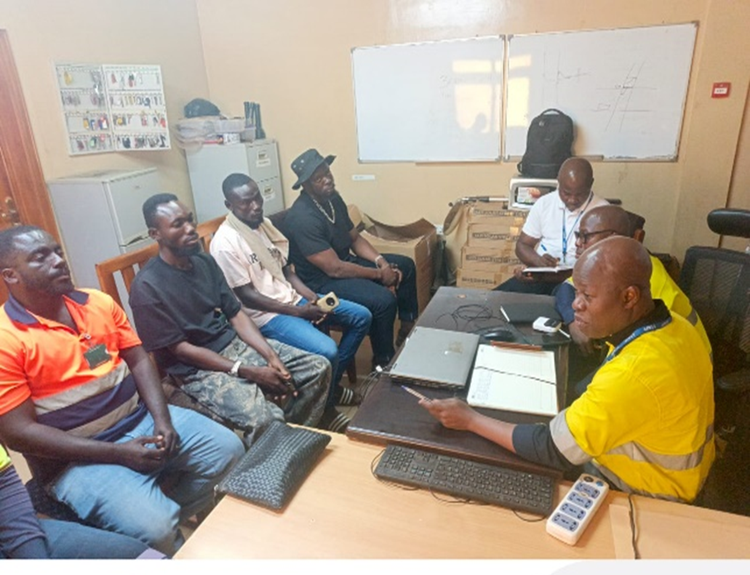
Picture showing ARL’s engagement with NAMOVA GH Ltd representatives and Abraham Kwofie
Picture showing ARL’s engagement with NAMOVA GH Ltd representatives and Abraham Kwofie
(SOURCE: ARL SEC 2026)
Picture showing ARL’s engagement with NAMOVA GH Ltd representatives and Abraham Kwofie

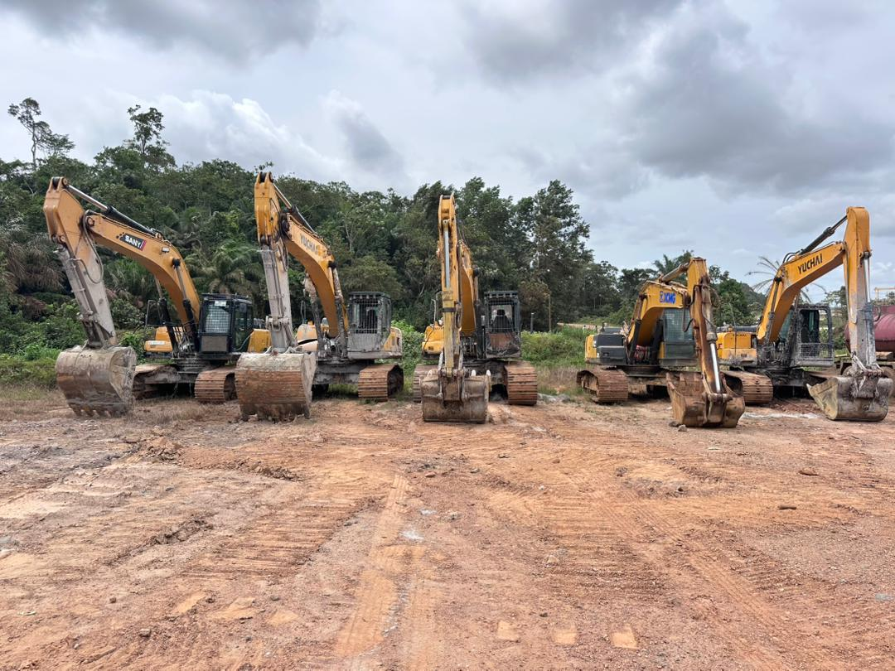
Excavator confiscated on 19th February 2026 at Old Salman Community Site.
Excavators confiscated at Akango South.
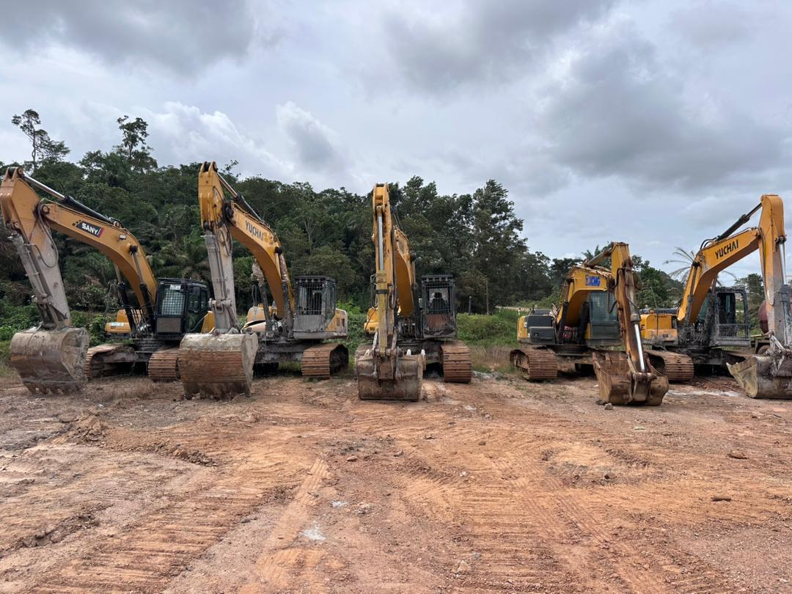(SOURCE: ARL SEC 2026)
Picture showing ARL’s engagement with NAMOVA GH Ltd representatives and Abraham Kwofie

